Accuracy of Model Predictions and the Effects of Atmospheric Stability on Wind Turbine Noise at the Maple Ridge Wind Power Facility, Lowville, NY - 2007

Clifford P. Schneider
P.O. Box 165
Cape Vincent, NY 13618
clif.schneider@yahoo.com
SUMMARY

New York State is currently on a “fast-track” for developing sources of renewable energy – the goal is renewable energy constituting 25% of all energy sold in New York by 2013. At present there are six commercial wind farms operating in New York State, with four more under construction. There are another 30 projects that are under some stage of environmental review, and there are undoubtedly more that are being considered. There are a number of important issues that confront developers in getting their projects approved; one of them is dealing with wind turbine noise.

Although wind farm noise may be low compared to a big municipal airport, in a quiet rural setting even low level noise can pose a significant problem. Wind power developers use mathematical models to predict the impact of wind turbine noise on nearby residents. However, no one knows if predicted noise impacts are high, low or on target. Developers, planning boards and residents are all assuming that model predictions are accurate and that they do not require any validation. Regrettably, there have been no compliance surveys done on any of the six operational wind farms in New York State.

The main objective of this study was to measure the noise levels at two sites within Atlantic Renewable Energy Corporation’s Maple Ridge Wind Power Project located in Lewis County, New York, and compare actual levels with the model predictions that were available in the preconstruction Draft Environmental Impact Statement (DEIS). The second objective was to examine atmospheric stability at Maple Ridge. Atmospheric stability was identified as a significant problem at a wind farm on the Dutch-German border. Stability occurs when ground level winds, where people live and reside, are decoupled from those at wind turbine hub-height. This can occur at the end of the day when the land mass begins to cool. It affects wind turbine noise because wind turbines can be operating and making noise when ground level winds are calm and we expect quiet surroundings.

This study demonstrated that summer, night-time noise levels exceeded levels predicted for two sites within the Maple Ridge Wind Farm. For winds above generator cut-in speed (e.g., 3.0 m/s @ 80-m), the measured noise was 3-7 dBA above predicted levels. The decoupling of ground level winds from higher level winds, i.e., atmospheric stability, was apparent in the noise data at both sites during evening and night-time periods. At wind speeds below 3.0 m/s, when wind turbines were supposedly inoperative, noise levels were 18.9 and 22.6 dBA above the expected background levels for each of the sites and these conditions occurred a majority of the time. The same results were evident in the evening period. Furthermore, digital recordings revealed prominent wind turbine sounds below cut-in speeds.

The fact that nearly all measurements exceeded Atlantic Renewable’s predicted impacts suggests there is a problem with the choice of a model and/or how the models are configured. The model protocol used by Atlantic Renewable is very common; most wind power developers in New York use the same protocol. However, different models used in wind farm noise assessments have been shown to produce different results, and the model used by Atlantic Renewable was not designed to model elevated sources of sound, i.e., wind turbines.

Several recommendations are suggested for planning boards, communities and the NYSDEC:

- The first step should be a validation of the results in this study. A small study should be undertaken quickly to confirm or refute these results. The consultant hired to do the work should be independent of any developer, preferably accountable only to NYSDEC.
- If the validation study confirms the conclusions in this study, the NYSDEC should make a strong recommendation in their comments to lead agencies to delay issuing any new permits (e.g., a moratorium) for wind farms until a more comprehensive assessment can be undertaken of all the operating wind farms in New York.
- Because atmospheric stability can have such a profound effect on wind turbine noise, planning boards and regulatory agencies should require developers to submit wind velocity summaries to describe prevalence of atmospheric stability.
- Wind power developers could do a much better job of predicting noise impacts if planning boards required noise compliance surveys, and if they imposed operation restrictions if actual noise exceeded predictions.
- NYSDEC should take a more involved and active role in reviewing noise impacts, to date their comments on wind turbine noise are minimal to non-existent. NYSDEC needs to get more involved in reviewing wind farm noise impact assessments.
- For those non-participating residents within the bounds of existing wind farms, depending on the results of the comprehensive review, it may be appropriate to find some means to mitigate excessive noise, i.e., additional payments and/or shutting down wind turbines during periods of stable atmospheric conditions.

INTRODUCTION

In New York State at the end of 2007 six commercial wind farms were operational, four were under construction and thirty others were under some stage of environmental review. Two of these projects, totaling 236 wind turbines, are proposed for the Town of Cape Vincent, NY, where I currently reside. The New York State Environmental Quality Review Act (SEQR) requires a careful, comprehensive review of all the potential impacts from any policy or project that could affect the environment, including commercial wind power development. For the two projects in Cape Vincent, developers have submitted Draft Environmental Impact Statements (DEIS) and they are in the process of revising and supplementing these reports. One of the most important issues that developers have to consider is wind turbine noise, particularly as it affects those residents outside of the wind farm project boundaries (AWEA 2008). In Europe, where commercial wind projects have been operating for years, there have been a number of instances where wind turbine noise has become a problem with non-participating residents. As a result, scientists have begun to study and document wind turbine noise impacts on community health

Annoyance with wind turbine noise is the most common complaint, but more serious health problems have begun to emerge as well. In a number of Swedish studies of wind farm residents, researchers found annoyance was related to wind turbine noise, as well as other factors, e.g., visibility, urbanization and sensitivity (Pedersen and Waye 2007). They also determined that wind farm noise was much more annoying than aircraft, road traffic and railway noise at far lower sound levels (Pedersen and Waye 2004). Wind turbine noise is principally broadband, white noise, which in itself is not particularly annoying. The character of wind turbine noise many people find annoying is called amplitude modulation, which relates to the periodic increase in the level of the broadband noise. Amplitude modulated noise can be simulated by tuning an AM radio between two stations, where static is heard, and then increasing the volume every 1-2 seconds. This is not pleasant. For some living within a wind farm, annoyance has lead to sleep disturbance (Pedersen 2003), which in turn can result in a low-level stress response and other potential health effects associated with stress.

The usual approach wind power developers use in assessing noise impacts is to: 1) conduct a background noise survey, 2) use noise propagation models to predict wind turbine noise impacts on non-participating residents, and 3) align these predictions to some local or state noise standards. In these noise assessments, wind power developers assert a cautious and conservative analysis, and assure us their models are configured so they produce conservative, worst-case scenarios. For example, in a recently completed noise study for the New Grange Wind Farm in Chautauqua County, New York there were thirty-six separate uses of the phrase “worst-case” (HWE 2008). The overall impression for anyone reviewing these reports is that developers use sophisticated, complex mathematical models to make very conservative estimates of noise impacts. The wind power industry, however, has overlooked the real worst-case scenario – the effect of atmospheric stability on wind turbine noise.

The Dutch environmental physicist, G.P. van den Berg, has published extensively on the relationship of atmospheric stability and wind turbine noise (2003, 2004, 2005 and 2006). During the day, the land is heated and the air rises and the near-ground atmosphere is considered unstable; winds that blow at ground level are even more intense at wind turbine hub-heights (e.g., 80m). At evening, the land begins to cool and vertical air movements disappear; wind can be calm near ground, but continue to blow strongly at hub-height. This is considered a stable atmosphere.

Atmospheric stability can have an acute effect on wind turbine noise, too. Wind turbine sounds are more noticeable, since there is little masking of background noise, and more importantly, because atmospheric stability can amplify noise levels significantl. Herein should be the developer’s worst-case scenario for their wind turbine noise impact studies: A still evening on the back patio with motionless flowers and trees, but with nearby wind turbines operating near full power and noise – much more noise than would be expected from a similar rural setting elsewhere. From what I have observed locally, atmospheric stability is not a rare phenomenon, on the contrary, it is very common.

In most wind farm noise assessments, however, they never mentioned atmospheric stability. Although stability is ignored by consultants doing noise exposure assessments, atmospheric stability is extremely important to developers who are trying to optimize electric power production: Choosing to ignore such diurnal effects (stability) would surely result in unreliable energy forecasts (Van Lieshout 2004). The commercial wind industry knows the importance of atmospheric stability for commercial wind power production; however, the industry ignores the issue when assessing noise impacts on rural communities.

I became interested in wind turbine noise when I was faced with proposals for two wind farm projects in Cape Vincent. I was also concerned about the complaints I heard from residents of Maple Ridge as well as those from other parts of the world via the web. In addition, I was suspicious about some of the claims and forecasts made by developers in their modeling of noise impacts. From my experience as a biologist I understand that models are not infallible and that follow-up studies are needed to validate model predictions. Regrettably, in New York there have been no noise compliance surveys done to date on any operating wind farm, nor are there any plans in the future for these kinds of studies (Tomasik 2008).

For these reasons, and because of the proximity of Atlantic Renewable Energy Corporation’s Maple Ridge Wind Power Project in Lowville, NY, I undertook a study of wind turbine noise in August and September of 2007. The objectives of my study were to 1) compare noise measurements during wind farm operation with model predictions outlined in the Maple Ridge DEIS, and 2) determine if the effects of atmospheric stability on wind turbine noise were as pronounced as that observed in Europe. I did not try to describe amplitude modulation and other characteristics of wind turbine noise, not because they are unimportant, but because I was limited in what I could do with my electronic equipment. Hence, the focal point of my study is wind turbine noise as it relates to pre-construction model predictions by Atlantic Renewable for their Maple Ridge Wind Facility.

METHODS

Two landowners within the Maple Ridge Wind Farm allowed me to set up equipment in August-September, 2007. The site referred to as SW1 (Fig.1) is the property of a wind farm cooperator and was one of Atlantic Renewable’s noise monitoring sites. SW1 is located on the Swernicki Road and there are six nearby wind turbines between 340 and 638 m (1,116-3,071 ft.). The other site, R14 (Fig. 1), is the residence of a non-participating landowner located near the Rector and Borkowski Roads, which has six wind turbines within 1,000 m; the closest two are both 382 m (1,250 ft.) away. These two sites were useful, because in the Maple Ridge DEIS (AREC 2003) noise predictions were tabulated for both sites and at five generator power settings associated with 80-m, hub-height wind speeds of 3.0, 6.4, 8.0, 9.5 and 12.0 m/s, respectively (Appendix B this report). In the subsequent methodology I tried to duplicate, as best I could, the locations, equipment, noise metrics and analytical approaches used by Atlantic Renewable in their noise report (AREC 2003).
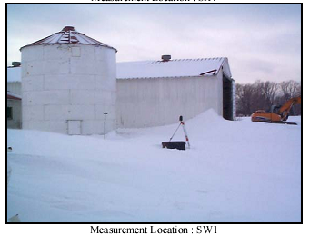
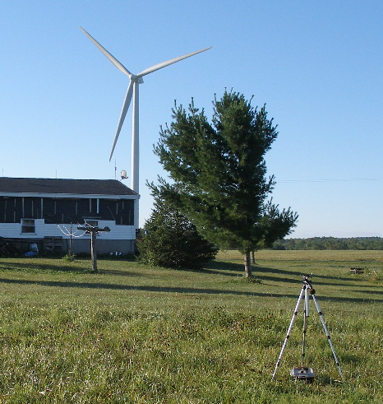
Figure 1. Two monitoring sites used for 2007 noise compliance study at Maple Ridge Wind Farm. Left is photo of R14 residence (keyed to Maple Ridge Wind Farm DEIS) and photo at the right SW1(2002 photo from DEIS). The close proximity of the sound measuring equipment to the buildings at the SW1 site was chosen to exactly duplicate the location used by the developer for their background noise survey in December, 2002.

For the noise measurements I used a Quest Model 2900 Type II Integrated and Logging Sound Level Meter. The meter was purchased on April 18, 2007 from Quest Technologies at which time they completed a factory calibration (Appendix C). Noise measurements were recorded for 10-minute segments for L_{eq}, L_{max}, L_{min} an L₉₀ metrics. The L_{eq, 10-min} measurement was the principal metric used in study in order to be compatible with Atlantic Renewable’s model forecasts. The limitations of the meter and microphone would not allow measurements below about 26 dBA, consequently, levels this low could have been even lower. The meter was fitted with a ½ inch electret microphone and a 75 mm diameter, closed-cell wind screen. Standard foam windscreens help reduce wind-induced microphone noise, but at moderate wind speeds they are not very effective.

Wind-induced microphone noise is a major problem in measuring noise levels associated with wind turbines, because wind not only drives wind turbine generators, but it can also contaminate noise measurements. Atlantic Renewable indicated that 5 m/s wind speeds at the microphone represented the upper limit for uncontaminated noise measurements in their background noise surveys (AREC 2003). Also, in their review of Australian wind farm assessment techniques, Teague and Foster (2006) recommend, “Time intervals for which the wind speed exceeds 5m/s (11.2 mph) at the receiver microphone need to be excluded from the data-set.” However, for the noise data collected in this study, I concluded that 5 m/s did not afford adequate protection, and assumed any noise measurements made in winds that exceeded 2 m/s were contaminated (see results section).

Due to a battery-life limitation, the time series for each session was limited to 35 hours of continuous operation. The night-time period was the main focus of these studies, because winds at night diminish and thereby make wind turbine noise more noticeable. In order to maximize night-time data collection, each session began in the evening of day-1 and was terminated the morning of day-3. For each set of batteries, two nights were sampled for each day. At the SW1 monitoring site the data collection periods were: Sept. 19-21: 18:30-06:36, Sept. 21-23: 19:46-06:35, and Sept. 23-25: 18:30-08:42 hrs. At the R14 residence sampling periods were: Aug. 27-29: 21:53-12:42, Aug. 29-31: 16:33-04:15. At each visit to setup equipment or replace batteries, nearby wind turbines were operating. At the beginning and completion of each of the surveys I conducted a field calibration of the sound level meter and none of the calibration tone levels varied by more than +/- 0.3 dBA.

Wind velocity data was collected using an Inspeed Vortex Anemometer with a Madgetech Pulse data logger. The anemometer and logger were located at the same height as the sound level meter (e.g., 1-m above ground level, agl), but approximately 15 meters away. Wind velocity was collected and correlated for the same 10-minute segments as that used for noise data. Atlantic Renewable referenced all their wind speed data to 80-m height, which meant I had to convert the 1-m velocities. To convert wind speed collected at ground level to 80-m, hub-height equivalents, I used the formula described by van den Berg (2006):
V_{80-m} /V_{1-m} = (h_{80-m} /h_{1-m} )^{m}

Where velocity of the wind at 80-m is a power function of the ratio of hub and anemometer heights. The shear exponent m is an expression of atmospheric stability. Van den Berg (2006) indicated that shear exponents near 0.20 represented moderately unstable atmospheric conditions and 0.41 represented a very stable atmosphere. In my calculation of 80-m velocities I used m= 0.20, identical to that used by Atlantic Renewable in their discussion of microphone noise effects (Section 5.6 AREC 2003). To provide a better understanding of the velocity conversions, with m= 0.2 the resultant ratio of 1-m to 80-m wind velocity was 2.4 – the winds at hub-height were 2.4 times that measured at 1-m. For comparison, velocities during stable conditions (e.g., m= 0.41), would be six times greater at hub-height than at ground level.

To assess the accuracy of my anemometer, I conducted a simple field calibration on a windless morning with the anemometer attached to a 2-m pole stretched out the window of my van. I first checked the accuracy of the van’s speedometer by measuring time and distance, and then compared a number of speeds from 4.6 – 18.1 m/s. There was close agreement between the anemometer and corrected speedometer (e.g., linear regression y=
9925x, r²= 0.9925, Fig. 2).

Beginning on September 5, 2007 I used an Olympus D30 digital audio recorder in conjunction with the sound level meter. The recordings were conducted using the monaural SP mode with a 22 kHz sampling frequency and an overall frequency response of 100-8,000 Hz. Each recording file had an elapsed time provision that enabled portions of the recording to be coupled with the corresponding noise level data. I was able to listen to the recordings and establish if turbine sounds were prominent. I also used SEA Wave sound spectrographic analysis software to examine the recordings and identify wind turbine, insects and other sound sources.
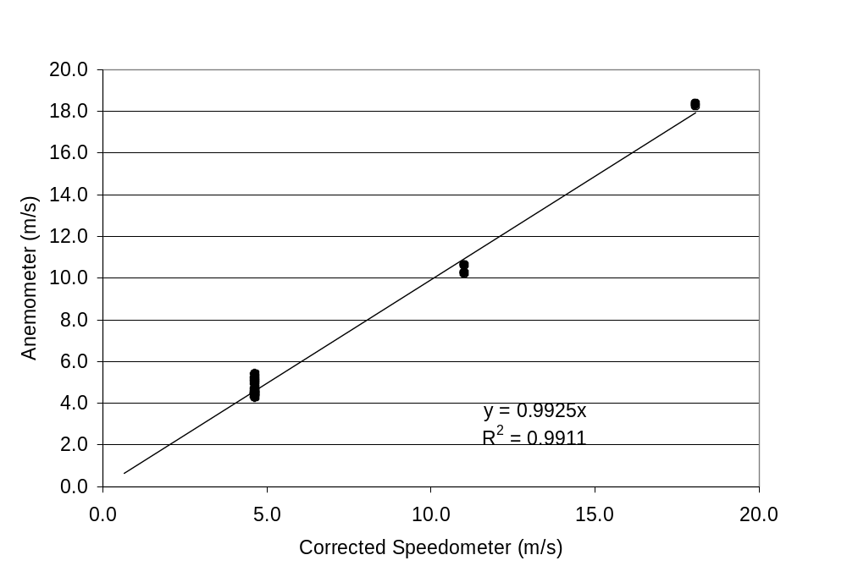
Figure 2. Relationship of Vortex anemometer wind speed to corrected motor vehicle speed. The anemometer was attached to a 2-m pole extended from the vehicle. The field calibration was conducted when ground level winds were non-existent.

At the completion of a survey, I downloaded both the noise and wind speed data and created a flat-file database with Microsoft Excel. I used the various plot and statistical functions of Excel to examine different aspects of the noise and wind speed data. The focus of the analysis was on evening and night-time, because these periods have lower background sounds and, consequently, wind turbine noise is potentially more noticeable.

RESULTS

Microphone Noise – All of the noise level data collected at during August-September, 2007 were plotted against wind speeds at 1-m, microphone height in Figure 3. Gross visual inspection shows a fairly flat response from 0-2 m/s, an inflexion point at approximately 2 m/s, and above this point noise increased with wind speed. For wind speeds above 2 m/s, the increases may be due to wind turbines, increased background noise or other sources, but undoubtedly also include wind-induced microphone noise. Without a more rigorous analysis than a gross inspection of the data and to be very cautious, I assumed noise data collected < 2 m/s were not contaminated by microphone noise. This limit is markedly less than the general guideline of 5 m/s used by others (AREC 2003, SAEPA 2006, Teague and Foster 2006), but it permits a fairly safe assumption that microphone noise will be minimal. Aside from the noise-time plots for the SW1 and R14 sites, only noise data collected at wind speeds < 2 m/s were included in the analyses of noise and wind speed. For subsequent noise/wind speed analyses, wind speeds of the selected data (e.g., < 2 m/s @ 1/m) were converted to wind speeds at 80-m heights using a neutral atmosphere profile in order to conform with Atlantic Renewable’s predictions (AREC 2003).
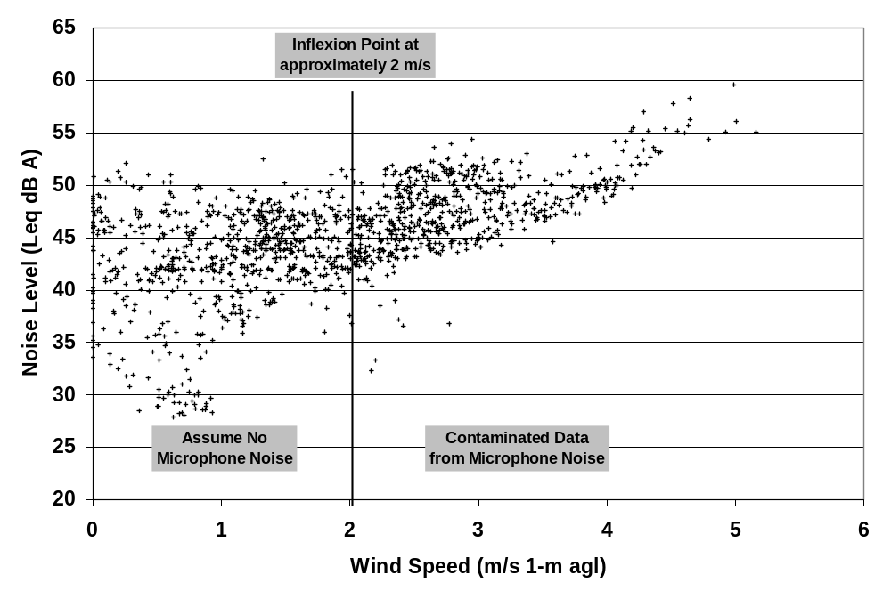
Figure 3. Noise levels (L_{eq}, _{10-min}) in relation to wind speeds at microphone level collected at SW1 and R14 monitoring sites at Maple Ridge Wind Farm, August-September, 2007 (n=1,325).

SW1 Monitoring Site – Between September 19 through 25, 2007, noise levels (L_{eq, 10-min}) at SW1 ranged from roughly 30 to 60 dBA, and averaged 43.6 dBA (Figure 4). Wind speed ranged from 0-12 m/s and was generally greater during the day. For a brief period during the early morning of September 20, noise levels dropped below 30 dBA, near background levels, but were never as low for the remainder of the SW1 surveys.
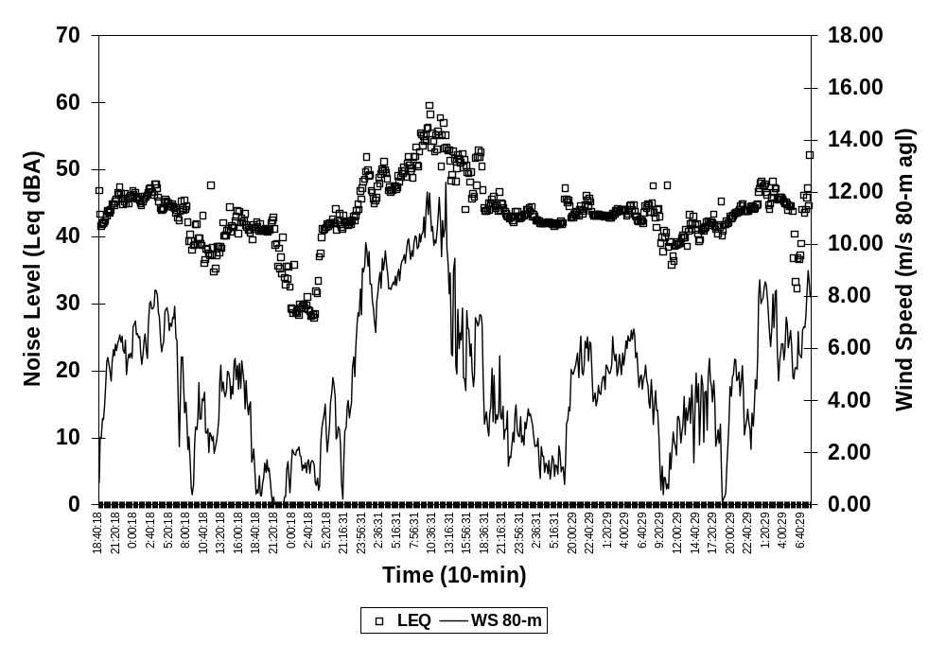
Figure 4. Noise (L_{eq 10-min}) and wind speed conditions at monitoring site SW1 at Maple Ridge Wind Farm from September 19-25, 2007.

The noise levels (L_{eq, 10-min}) measured at night at SW1 were plotted against selected and converted wind speeds from September 19-25, 2007 (Fig. 5). Included in the plot are Atlantic Renewable’s predicted noise impacts for the various 80-m wind speeds associated with cut-in and ¼ power settings (3.0 and 6.4 m/s) for the wind generators. The results are presented in a similar format as that used in their Maple Ridge DEIS (AREC 2003, Appendix C this report). In addition, the average night-time L₉₀ background noise was calculated and plotted using the polynomial regressions provided in the Maple Ridge DEIS (AREC 2003).

Above cut-in speed (e.g., >3.0 m/s), noise estimates (L_{eq, 10-min)} were up to 5 dBA above predicted levels and averaged 43.3 dBA; 3.4 dBA above predictions. None fell below the line denoting predicted noise levels.

Below cut-in speed, when wind turbines were expected to be inoperable, there were three groupings of noise data: 1) 54% were above 40 dBA, 2) 25% were below 30 dBA, and 3) 23% were between 30-40 dBA. The dark squares in Figure 5 represent those segments where the digital recordings were examined for the presence of wind turbine sounds. Review of these recordings showed that those above 40 dBA were dominated by wind turbine noise, and averaged 42.5 dBA or 22.6 dBA above the expected background L₉₀ level. There was no wind turbine noise for those segments where noise levels were at or below 30 dBA.
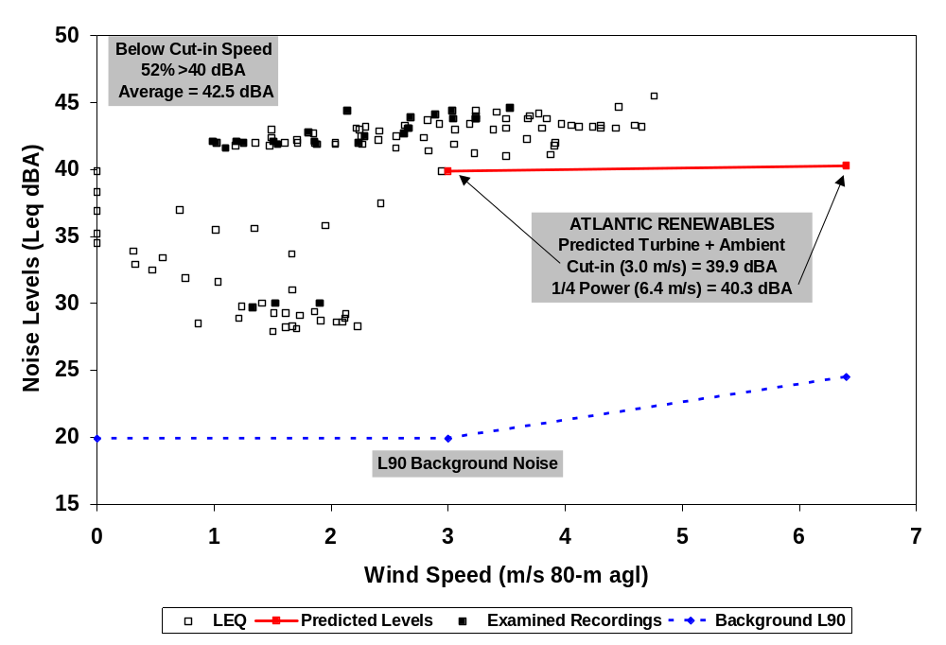
Figure 5. Night-time (22:00 – 06:00 hrs.) noise levels (L_{eq 10-min}) measured at SW1 monitoring site, Maple Ridge Wind Farm, September 19-25, 2007. Solid line represents the predicted noise from the Maple Ridge DEIS (AREC 2003). The dashed L₉₀ background noise was calculated from Atlantic Renewable’s regression formulas. Solid squares are those segments where companion digital recordings were examined to establish noise sources.

R14 Residence – Shortly after this R14 survey was initiated, on the morning of August 27, the L_{eq, 10-min} noise levels dropped to 28.9 dBA, which was presumably near background noise levels (Fig. 6). This level was also preceded by a period of diminished wind velocity, but aside from the drop in noise (L_{eq, 10-min)} in the beginning of this survey, noise levels were remarkably consistent, ranging from 40-50 dBA, averaging 46.8 dBA (Fig. 6). This consistency was maintained during both day and night periods and during substantial changes in wind velocity.
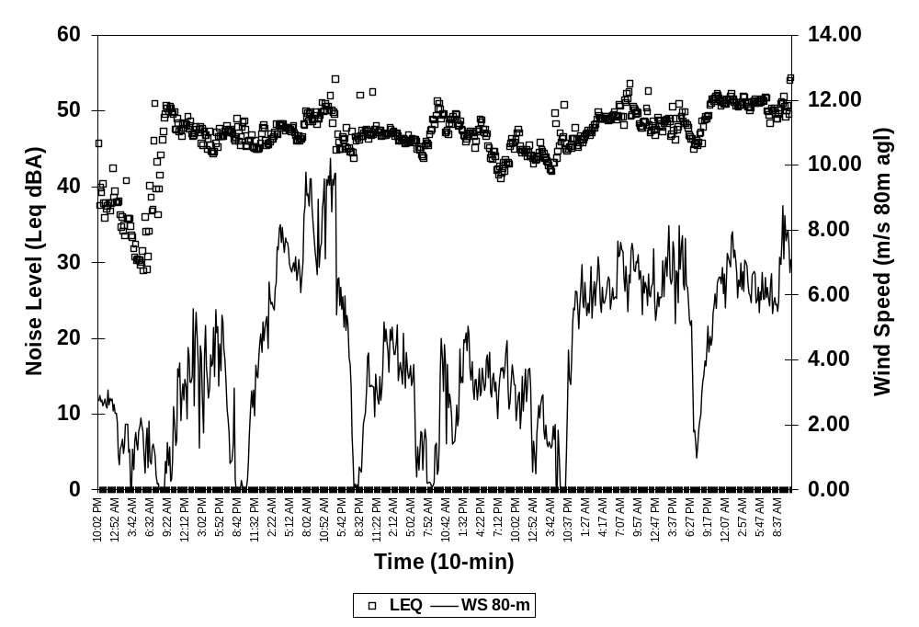Figure 6. Noise (L_{eq 10-min}) levels(open squares) and wind speed (solid line) at monitoring site R14 at Maple Ridge Wind Farm from August 27-31, 2007.

The plot of night-time noise levels on wind speed at R14 was similar to SW1, albeit measured noise exceeded predictions by an even greater amount (Fig 7). Above cut-in speeds noise levels averaged 46.1 dBA, exceeding predicted noise by more than 7 dBA; none of the observed noise values were close to predicted levels. Examination of the few available digital recordings (black squares) showed that the noise above cut-in wind speeds was comprised of both wind turbine and insect noise. Higher noise at R14 compared to SW1 was likely attributable to insects, since insect sounds were not well-defined in the SW1 recordings.

Below cut-in speed 54% of the noise segments were above 40 dBA (equivalent to the predicted noise at cut-in), 42% were between 30-40 dBA, and 4% were at or below 30 dBA. Fewer noise levels were less than 30 dBA compared to SW1 (25%), and again, this was most likely related to prominent insect noise at R14.

The Maple Ridge DEIS used background levels observed at the R3 monitoring site as a surrogate to measuring background levels at R14 (AREC 2003). Compared to the average R3 L₉₀ background noise below cut-in speed (e.g., 25.8 dBA), wind turbine noise at R14 was 18.9 dBA louder than expected.

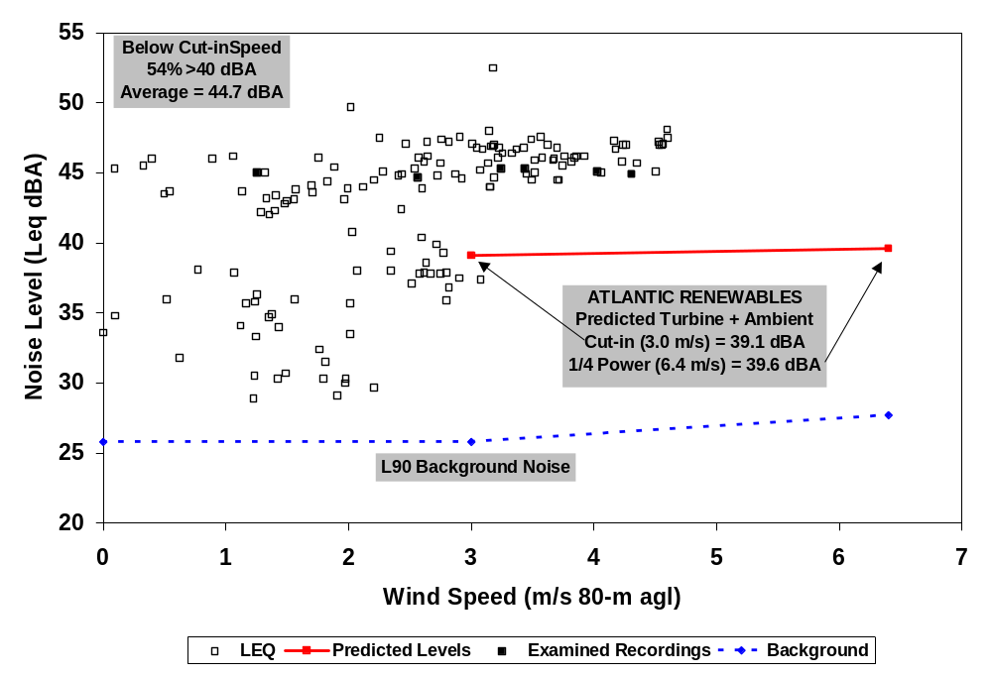
Figure 7. Night-time (22:00 – 06:00 hrs.) noise levels (L_{eq 10-min}) measured at R14 monitoring site, Maple Ridge Wind Farm, August 27-31, 2007. Solid line represents the predicted noise from the Maple Ridge DEIS (AREC 2003). The dashed L₉₀ background noise was calculated from Atlantic Renewable’s regression formulas. Solid squares are those segments where companion digital recordings were examined to establish noise sources.

Evenings and Atmospheric Stability – During the evening at Maple Ridge, when I was setting up the equipment for the noise surveys, I noticed that ground conditions were very calm, yet nearby wind turbines were operating and their noise was very noticeable. I expected this example of stable atmospheric conditions at night, but was surprised it was so obvious late in the day, too. Consequently, I examined a subset of the daytime data from 17:00 to 22:00 hrs looking for evidence of atmospheric stability and elevated noise. The L_{eq, 10-min} noise levels for the evening period of both SW1 and R14 surveys are plotted in Figure 8. Although Atlantic Renewable provided no noise predictions for wind turbines operating in evening, I used their daytime predicted noise levels for SW1 as a surrogate and reference (actually evening background levels and predictions would probably be lower because evenings seem quieter than daytime). Above cut-in speeds (e.g. 3 m/s) the observed noise exceeded daytime predictions for all segments, both at SW1 and R14, similar to what was observed during night-time. Again, elevated noise levels were prevalent below cut-in speeds, as well, i.e., all but three segments were above the 40 dBA level.
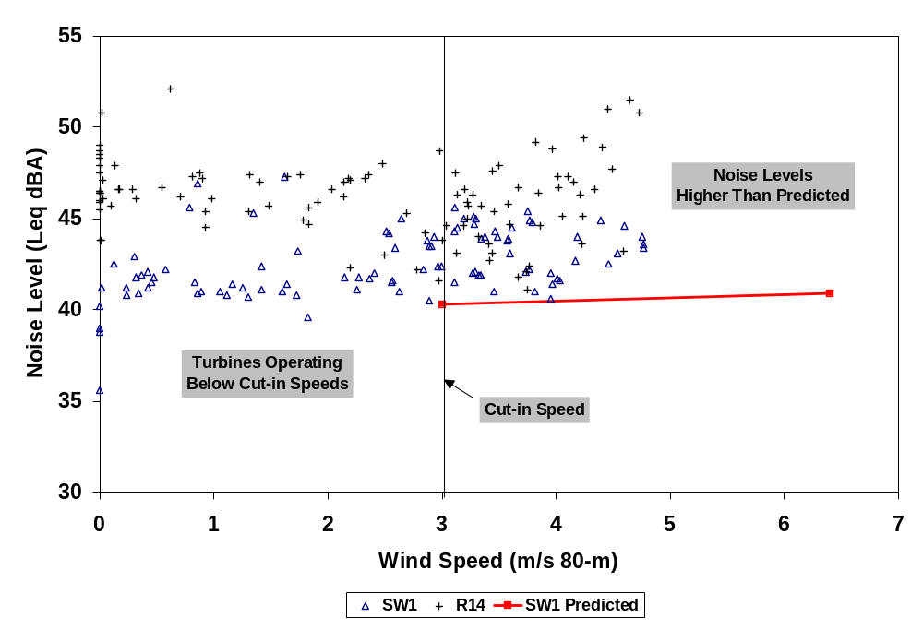
Figure 8. Relationship of noise level (Leq, 10-min) to wind speed for EVENING HOURS (17:00 – 22:00 hrs) at the SW1 and R14 sites at the Maple Ridge Wind Farm, August and September, 2007.
DISCUSSION

Microphone noise contamination of background noise surveys is an issue that has received a lot of attention and criticism. It was a major concern in this study, as well. In an effort to remove any possibility of wind-induced microphone noise contamination, all of the data associated with wind speeds in excess of 2 m/s were purged -- 65% of the 1,325 noise and wind speed data were removed. The 2 m/s cut-off was far more restrictive than the 5 m/s upper limit used by Atlantic Renewable and recommended by others (Teague and Foster 2006). The effect of this more cautious approach, however, was to greatly reduce the potential for wind-induced contamination of the noise data, and thereby ensure better, more reliable noise data.

Atlantic Renewable stated in their DEIS (AREC 2003) that their impact assessment is “... likely a worst-case assessment of the noise impact from the proposed wind farm.” This was clearly not the case, however. For winds above generator cut-in speed, average noise exceeded predicted impacts by 3.4 to 7.0 dBA for SW1 and R14, respectively. The decoupling of ground level winds from higher level winds, i.e., atmospheric stability, was apparent in the noise data at both sites during evening and night-time periods. Below cut-in speeds, when wind turbines were supposedly inoperative, noise levels were 18.9 and 22.6 dBA above the expected background levels for R14 and SW1, respectively. Moreover, below cut-in speed the majority of these observations (average 53%) exceeded the predicted noise for cut-in wind speed.

It is apparent that Atlantic Renewable missed or avoided a very important potential impact of wind farm noise. Although they went through the required second level analysis outlined in the NYSDEC noise policy (NYSDEC 2001), they failed to predict a 20+ dBA noise impact in calm conditions that is deemed by the NYSDEC as “very objectionable to intolerable.” NYSDEC policy further states, “When the above analyses indicate significant noise effects may or will occur, the applicant should evaluate options for implementation of mitigation measures that avoid, or diminish significant noise effects to acceptable levels.” Atlantic Renewable should have done more to mitigate the impacts of atmospheric stability.

Not only did Atlantic Renewable fail to consider noise impacts related to atmospheric stability, but also, they mislead when they stated, “However when the wind speed is low, a wind turbine will not operate and as such, no noise impact will occur [AREC 2003].
This is true at hub-height, since wind turbines need wind to operate, but it is not the case at ground level where people live. The results of this study refute any insinuation or suggestion by developers that noise will not be a problem when the wind is not blowing, and these results are also compatible with other studies documenting the effects of atmospheric stability (van den Berg 2003, 2004, 2005 and 2006). Contrary to the assertions of Atlantic Renewable, wind turbines can operate without wind. The key to this contradiction is to better understand atmospheric conditions.

The reason why wind turbines appeared to be operating below cut-in speeds is because estimates of hub-height (80-m) wind velocity were erroneous. Typically, developers use a neutral atmospheric profile to convert wind speeds from one height to another. I used the same neutral atmosphere wind profile as Atlantic Renewable to calculate 80-m wind speeds, but it was apparent the evening and night-time meteorological conditions at this time at Maple Ridge were typically stable; not neutral. Therefore, Atlantic Renewable’s use of a neutral atmospheric profile to estimate microphone level noise from 80-m tower height winds would have substantially underestimated the actual wind velocity. This in turn would indicate that microphone noise contamination was a bigger problem in their original background noise study than they had previously thought, i.e., they overestimated background noise.

Therefore, because atmospheric stability is such a prevalent condition, in modeling noise impacts Atlantic Renewable and other developers need to consider stable atmospheric profiles and not limit their analysis to neutral conditions. Furthermore, with all the years of study of the winds at these proposed wind farm project sites, it is difficult to believe that developers do not fully understand the extent of atmospheric stability, temperature inversions and other meteorological phenomena. Also, these issues are far more important today, because modern wind turbines are considerably taller than earlier versions, and hence, there will be greater disparities between ground and hub-height wind speeds. The noise consultant to Atlantic Renewable at Maple Ridge recently completed a noise survey of a gas-fired electric generation facility in New South Wales Australia and noted: The wind speed profile with height can also have an influence on the propagation of noise from the source to the receiver. When there is a significant increase in wind speed with height, the sound emitted to the atmosphere by the source undergoes refraction back towards the surface. This can cause a significant increase in the sound propagation to receptor locations downwind of the source (Hayes McKenzie APW 2007). They went on to indicate the effects of atmospheric stability can increase noise by 5-10 dBA and that the direction of the wind had a substantial influence on the noise perceived at nearby residences. It is apparent developers know about the impact of atmospheric stability, and they undoubtedly know how frequently it occurs, too.

Given the inaccuracies of Atlantic-Renewable’s predictions, the obvious question is how could their predictions be so far off the mark, especially when Atlantic Renewable’s predictions supposedly represent a worst-case scenario? At first glance, we might wonder if the developer substituted a different wind generator from what was described in their DEIS, one that had a higher source level. Atlantic Renewable’s noise predictions were based on an A-weighted source level of 103.3 dBA at rated power. Another make or model could increase source levels by about 3 dBA, enough to explain some of the discrepancies in their predictions. I also know there were some apparent problems with the tips of the wind turbine blades, and I saw technicians working on the wind turbine blade tips. Since most of the aerodynamic noise is generated at the blade tips, possibly modifying the blade tips could have altered the noise characteristics of the wind turbines, thereby increasing wind turbine aerodynamic noise. On the other hand, I did not see any maintenance activity associated with wind turbines close to SW1 or R14.

Another possible explanation might be the selection of an inappropriate noise propagation model. Teague and Foster (2006) noted: The CONCAWE model overpredicted relative to the other models (by about 1 dB relative to Nord2000, by about 4 dB relative to GPM and by up to 6 dB relative to ISO9613.” The ISO9613 model was used by Atlantic Renewable for Maple Ridge assessments, and compared to the others appears to underestimate predicted impacts. Furthermore, the accuracy of the ISO9613 protocol is +/-3 dBA, without considering reflected sounds, and it is not recommended for source levels higher than 30m (ISO 1996).

Using appropriate models properly configured is not only an issue for Atlantic Renewable, but it should be important for all wind power developers in New York State because they all use the same ISO9613 model to predict noise impacts. Teague and Foster (2006) warn, The application of modeling software to specific situations needs to be carefully considered and, where possible, based on validations with actual measurement data to provide confidence and minimize associated inaccuracies. As noted earlier, there have been no model validation studies for any of the New York wind farm projects to date, and it is obvious from the results of this study that compliance surveys represent a critical need.

Reviewing agencies, planning board members and the general public need to be aware of misleading claims that modeled noise predictions represent worst-case conditions. A true worst-case scenario should include winter, night-time L₉₀ background levels modeled under stable atmospheric conditions, using a conservative, appropriate noise propagation model.

What about Cape Vincent and other communities that are now faced with evaluating environmental assessments by developers who may make many of the same assumptions, claims and predictions as Atlantic Renewable at Maple Ridge, what should they do? The following suggestions may help us all do a better job of assessing noise impacts from proposed wind farms in New York:

- The first step should be a validation of the results in this study. I do not claim to be an acoustic consultant or engineer. Consequently, a small study should be undertaken quickly to confirm or refute these results. The consultant hired to do the work should be independent of any developer, preferably accountable only to NYSDEC.
- If the validation study confirms my results, the NYSDEC should make a strong recommendation in their comments to lead agencies to delay issuing any new permits (e.g., a moratorium) for wind farms until a more comprehensive assessment can be undertaken of all the operating wind farms in New York. Again, the comprehensive study should be done by professionals who are independent from commercial wind power developers, accountable only to the NYSDEC.
- Because atmospheric stability can have a profound effect on wind turbine noise, municipal planning boards should require developers to submit wind velocity data in order to establish the incidence of atmospheric stability at each proposed wind farm site. These summaries should include hourly averages of wind speed at different heights above ground level, along with ratios of velocity, e.g., 1-m:80-m. This should be completed for a recent calendar year.
- I was fortunate that atmospheric stability was such a common event at Maple Ridge. It allowed me to assess wind turbine noise impacts with little or no wind-induced microphone noise from ground-level winds. Because wind-induced noise is such a serious problem with assessing wind farm noise impacts, this approach of focusing on a compliance survey using night-time and evening periods minimizes potential microphone noise contamination. Van den Berg (2006) makes the same point, …to reduce wind induced sound, it helps to measure over a low roughness surface and at night (stable atmosphere), as both factors help to reduce turbulence, even if the (average) wind velocity on the microphone does not change.
- From my experience to date, I believe the wind power industry can do a better job predicting wind turbine noise impacts, in spite of the results from this study. However, running models, predicting noise impacts and comparing them to standards is not sufficient. As any traffic cop knows, posting a speed limit does not guarantee all drivers will comply – you need enforcement, too. Wind power developers will do a much better job predicting impacts if they understand that post-operational noise surveys will be done, and if they exceed their predictions then operational restrictions will be imposed, such as a shut down of wind turbines during stable atmospheric conditions.
- NYSDEC should take a more involved and active role in reviewing noise impacts. Their comments to date focused primarily on bird and bat issues with few comments directed to wind turbine noise. NYSDEC needs to get more involved with noise issues.
- For those non-participating residents within the bounds of existing wind farms, depending on the results of the comprehensive review, it may be appropriate to find some means to mitigate excessive noise, i.e., additional payments and/or shutting down wind turbines during periods of stable atmospheric conditions.

Acknowledgements

I especially want to thank Judith and John Wilagori and Rick Beyers for permitting me to use their property for my study. I also appreciate the helpful suggestions provided by Richard Bolton and Charles Ebbing.

References

Atlantic Renewable Energy Corporation (AREC). 2003. Draft Environmental Impact Statement for the Flat Rock Wind Power Project. Prepared by: Environmental Design and Research, P.C. Syracuse, NY. p.127.
American Wind Energy Association (AWEA). 2008. Wind Energy Siting Handbook – Chapter 5 Impact Analysis and Mitigation. Washington, D.C. p. 62.

Bolton, R.H. Environmental Compliance Alliance. Personal communication. March 20, 2008.
Hayes McKenzie APW. 2007. Power and Water Corporation - Ron Goodin Power Station Noise Impact Follow-Up Assessment. Report no. 08.501D. p. 137.

Horizon Wind Energy (HWE). 2008. Environmental Sound Survey and Noise Impact Assessment. New Grange Wind Farm, LLC. Prepared by: Hessler Asscociates, Inc. February 7, 2008. p. 65.

ISO. 1996. Acoustics - Attenuation of sound during propagation outdoors - Part 2: General method of calculation. International Organization of Standardization. ISO 9613-2. p. 18.

New York State Department of Environmental Conservation (NYSDEC). February 2, 2001. Assessing and Mitigating Noise Impacts, Program Policy. Albany, New York.

Pedersen, E. 2003. Noise Annoyance from Wind Turbines – A Review. Swedish Environmental Protection Agency Report. p. 26.

Pedersen, E. and K. Persson Waye. 2004. Perception and annoyance due to wind turbine noise- a dose-response relationship. J. Acoust. Soc. Am. 116:6 December 2004. p.3460-3470.

Pedersen, E. and K. Persson Waye. 2007. Wind Turbine Noise, Annoyance and Self-Reported Health and Wellbeing in Different Living Environments. published online 1 Mar 2007; Occup. Environ. Med. p. 20.

Russell, J. An Idyll Lost in Turbines’ Humming – Neighbors Regret Maine Wind Farm. February 17, 2007.

South Australia Environmental Protection Authority (SAEPA). 2003. Environmental Noise Guidelines: Wind Farms. February 2003. p. 18.

Tomasik, S. NYSDEC. Personal communication. March 14, 2008.

Van den Berg G.P. (2003): “Wind turbines at night: acoustical practice and sound research”, Proceedings Euronoise2003, Naples

Van den Berg G.P. (2004): "Effects of the wind profile at night on wind turbine sound", Journal of Sound and Vibration 277 (4-5), pp. 955-970

Van den Berg, G.P. (2005): “The beat is getting stronger: the effect of atmospheric stability on low frequency modulated sound of wind turbines”, Journal of Low Frequency Noise, Vibration And Active Control24 (1), pp. 1-24

Van den Berg, G.P. 2006. The sounds of high winds: the effect of atmospheric stability on wind turbine sound and microphone noise. PhD Dissertation. University of Groningen. Groningen, The Netherlands.

Van Lieshout, P. 2004. Time Dependent Energy Calculations. Proceedings ‘Wind flow and Trees’ Workshop, British Wind Energy Association, Glasgow, UK. P. 4.

Appendix A Background Experience:

I graduated from Cornell University in 1965 and began work with the New York State Department of Environmental Conservation Department as a fishery biologist. Between 1967 and 1970 I served with the U.S. Marine Corps as an electronics technician. I completed over nine-months of technical schooling that included basic electronics, radio theory and repair, and cryptographic training. In addition, I also completed an intensive U.S. Air Force program in the calibration and repair of electronic test equipment. As a Marine electronics tech I worked in a calibration lab for over a year, and for the remainder of my service time I oversaw a radio repair facility at a Marine Airbase in Hawaii. After my service commitment was completed I returned to my job as a biologist working at the Cape Vincent Fisheries Station. In 1978, I completed a short-course on Hydroacoustic Fish Stock Assessment at the Applied Physics Lab at the University of Washington. During my work with hydroacoustics I became familiar with source levels, noise propagation losses and other acoustic principles. In 1980, I also attended a workshop at the University of British Columbia that focused on simulation modeling of biological systems, which provided some insight into the development and use models to help guide the management of fisheries resources. In the course of my 34 year career I have been an author in more than 25 peer-reviewed journal reports. The last task I completed for the NYSDEC was to lead an investigation of Double-crested Cormorant impacts on fish populations in Lake Ontario. I retired in 1999 as the Lake Ontario Unit Leader at NYSDEC’s Cape Vincent Fisheries Station.
Appendix B Maple Ridge DEIS Data
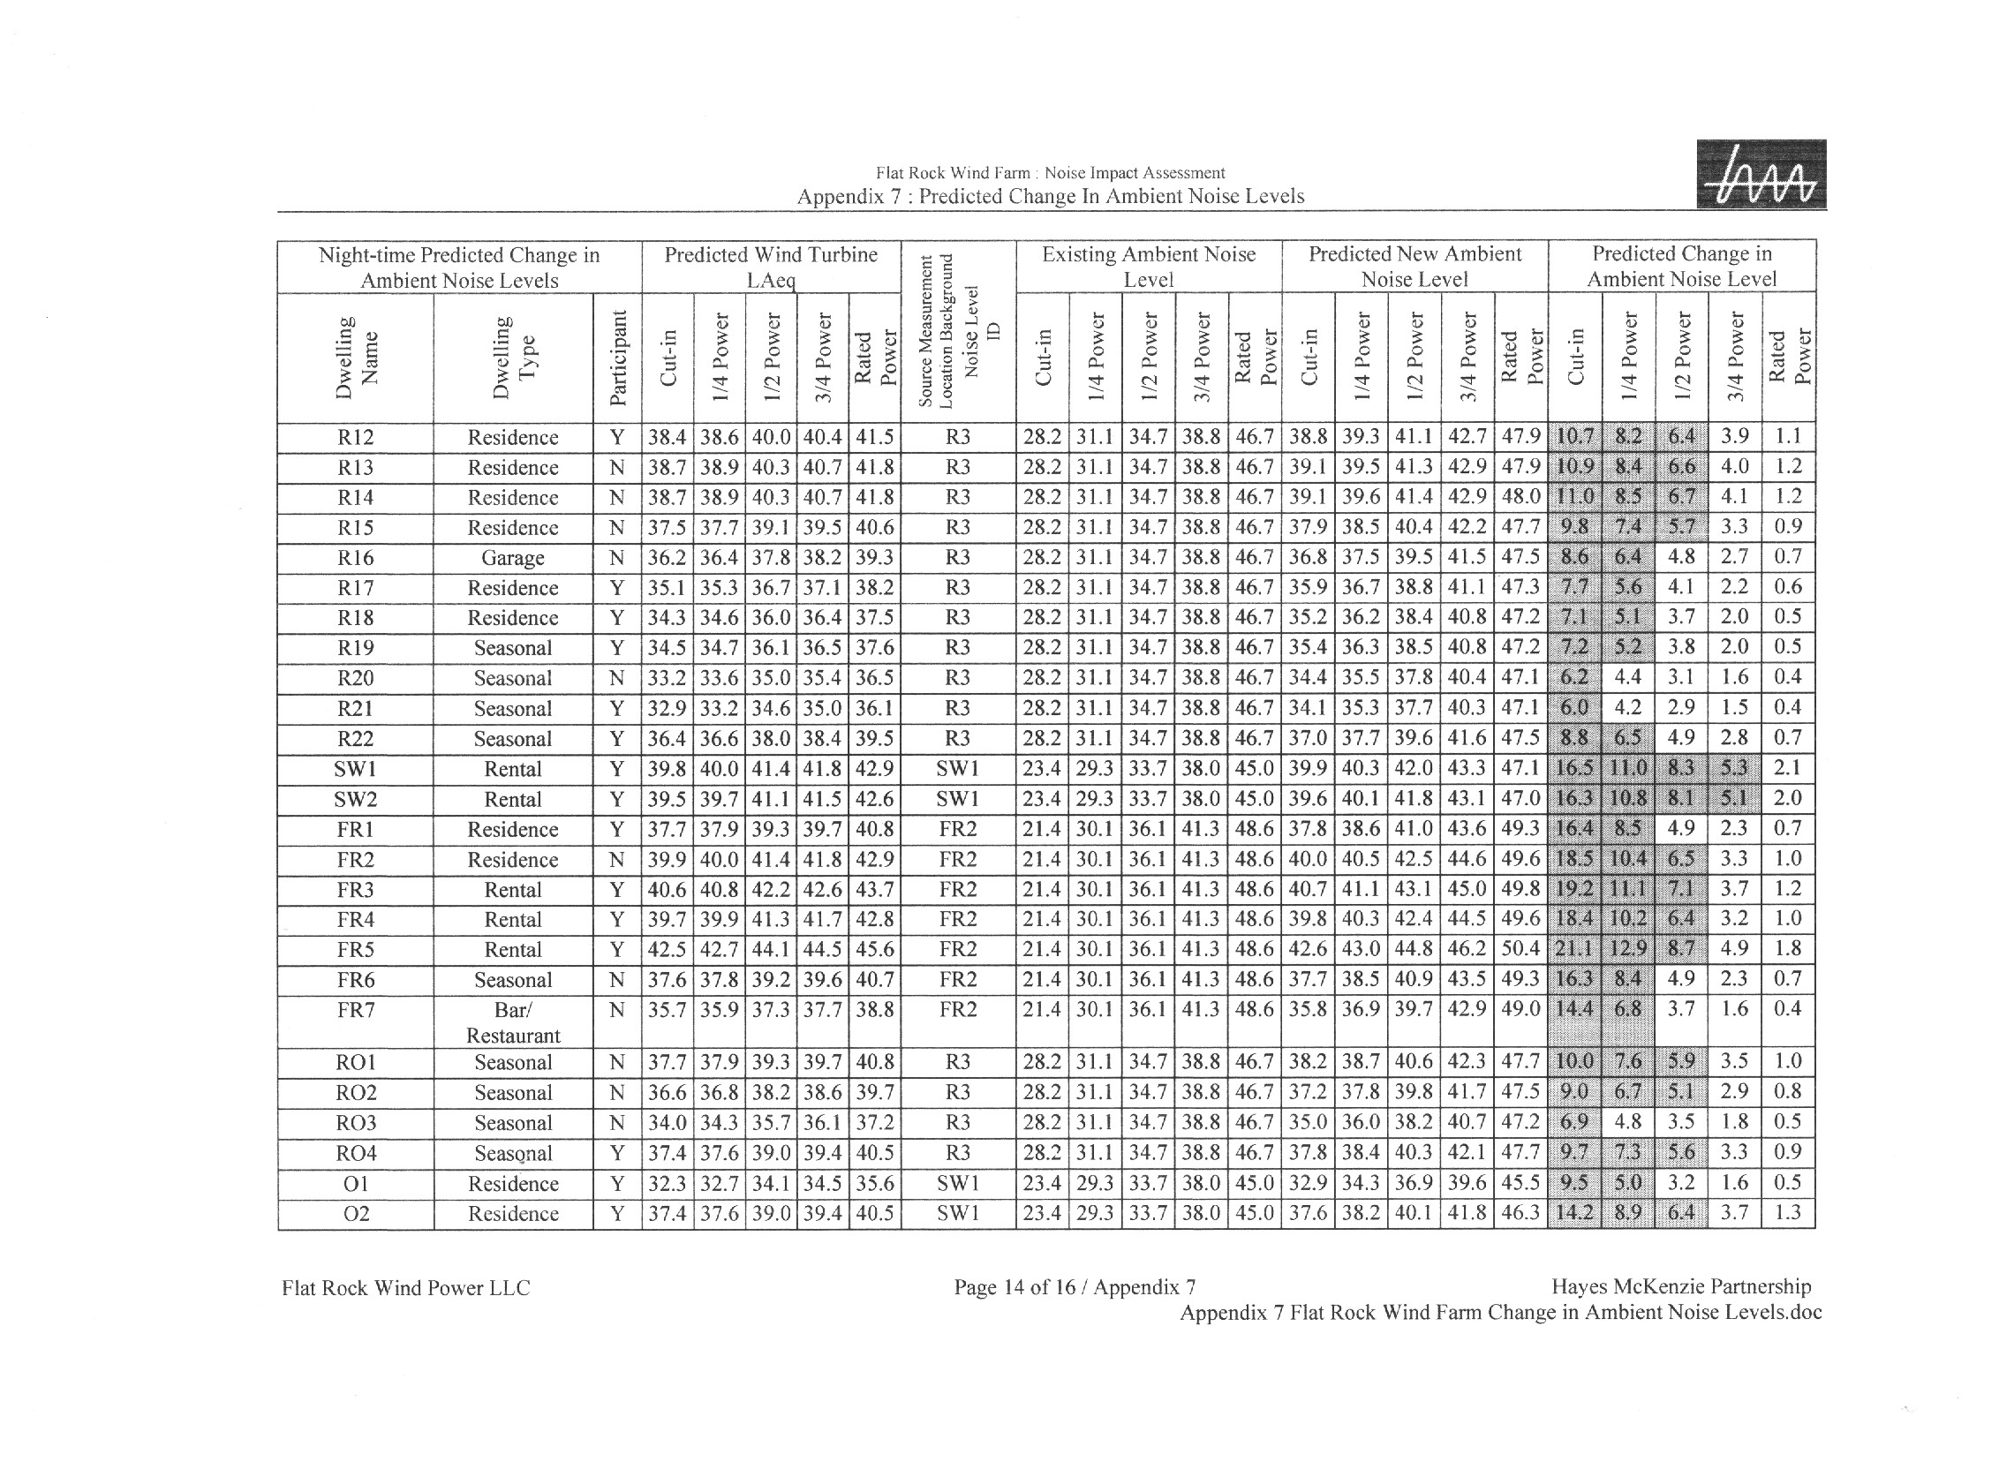
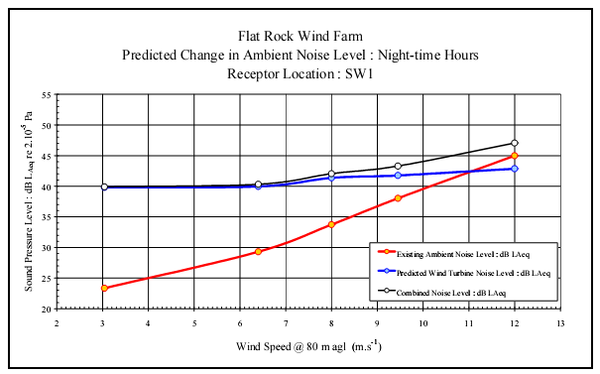
Example of Maple Ridge DEIS predicted impacts for SW1 Receptor.
Appendix C
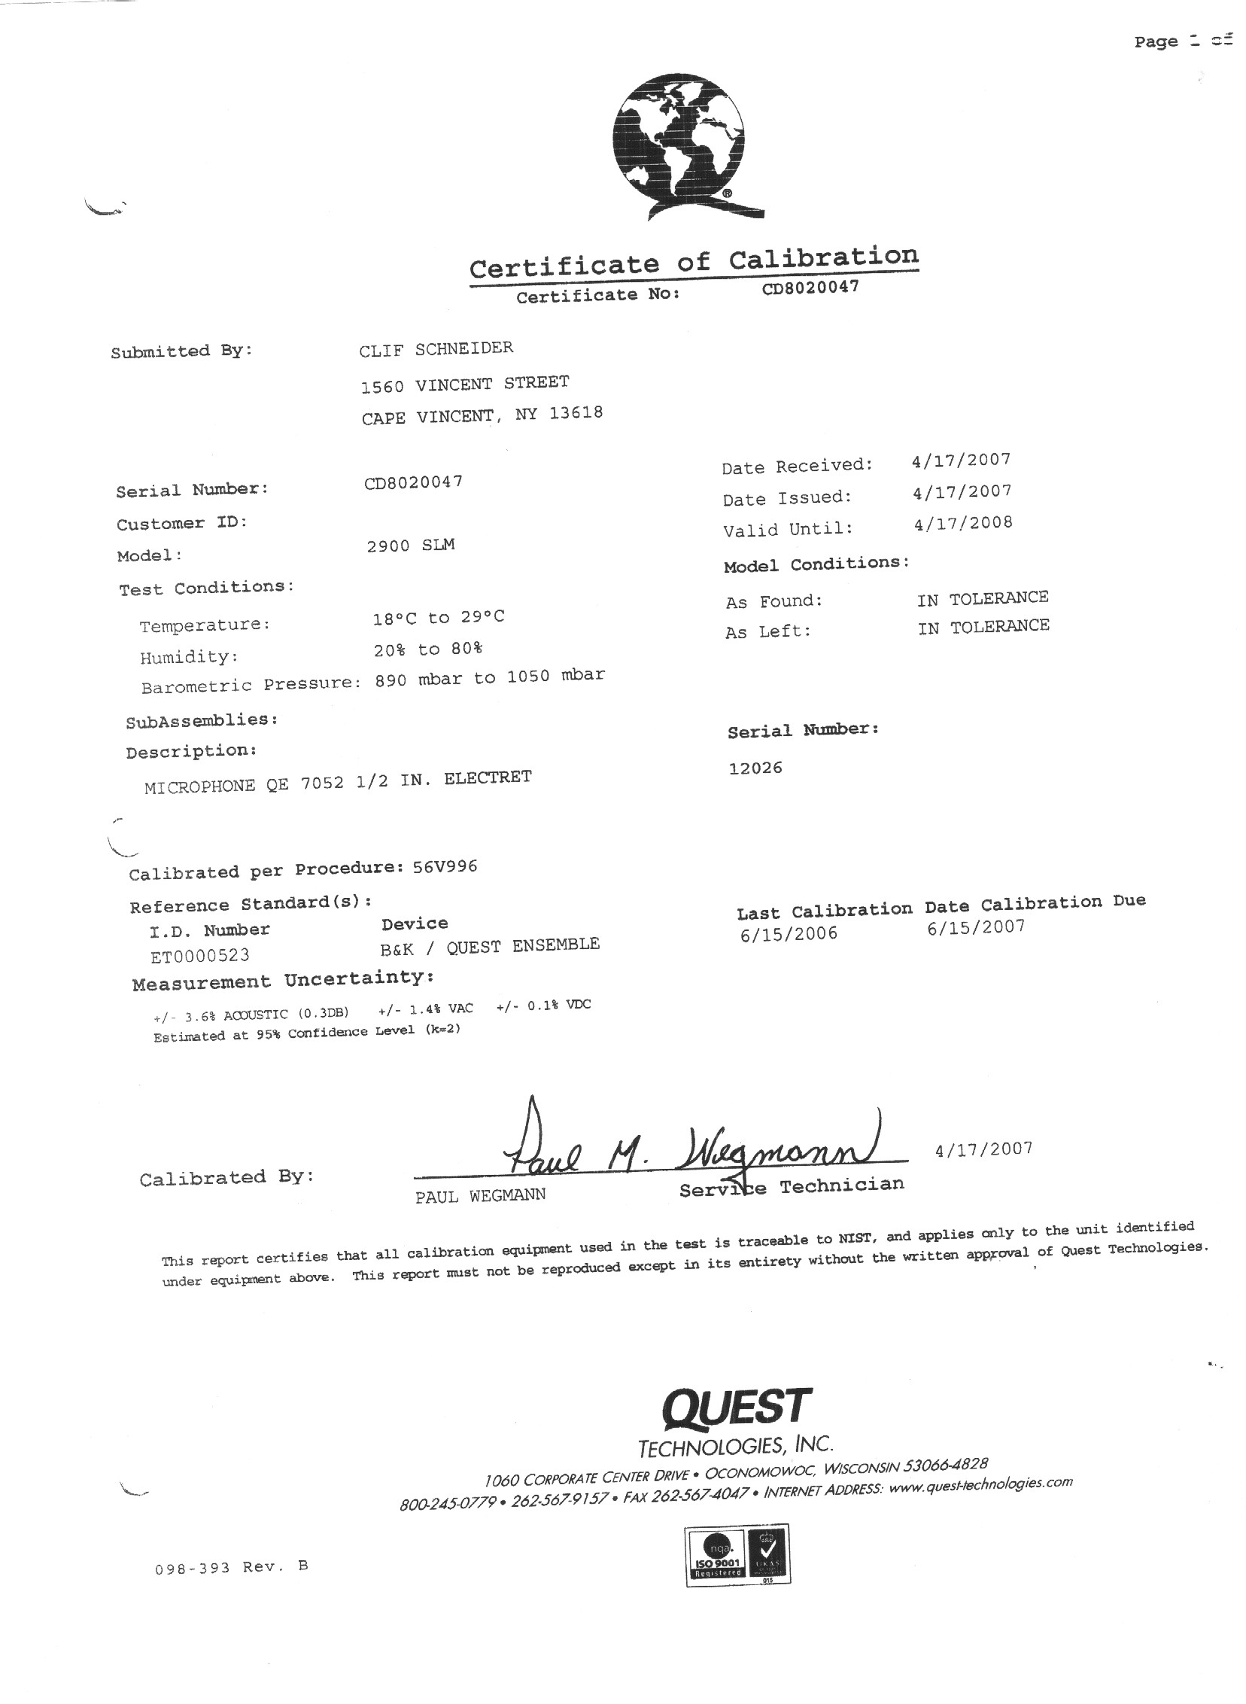

Retired Lake Ontario Unit Leader, Cape Vincent Fisheries Station, New York State Department of Environmental Conservation (NYSDEC), Cape Vincent, NY, see Appendix A for background and experience.
http://www.dec.ny.gov/energy/40966.html
The DEIS for the Maple Ridge Wind Power Project was originally titled Flat Rock Wind Power Project DEIS.
http://www.inspeed.com/anemometers/Vortex_Wind_Sensor.asp
SEA Wave – Sound Emission Analysis
Use of the digital recorder began after most of the R14 survey was completed.
The dBA difference between predicted and measured levels may seem small, but noise is measured in a logarithmic, not linear scale.
General Prediction Model, Nordic.

